**ASSIGNMENT 4.3**

(2403A510E3,Gattu Varshith)

----------------------------------------------------------------------------------------------------------------

**Task-1:**

**PROMPT :**

🡪leap year check

**SCREENSHOT:**

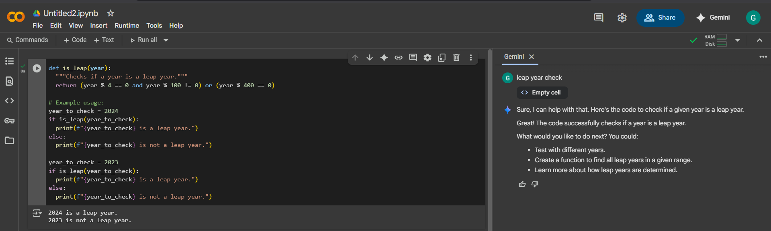

**CODE -EXPLANATION:**

This code defines a function is_leap() that determines if a given year is a leap year. The function returns a boolean (True or False) based on the established rules for leap years, implemented using **modulo operators (%) and logical operators (and, or)**. The rest of the script is an example usage block that calls this function with test years (2024 and 2023) and prints a formatted string indicating whether each is a leap year or not.

---------------------------------------------------------------------------------------------------------------------------

**Task-2:**

**PROMPT :**

🡪 generate a python code which converts centimetres to millimetres   
 INPUT : Enter Value in centimetres __  
 OUTPUT : __ is the value in inches

**SCREENSHOT:**

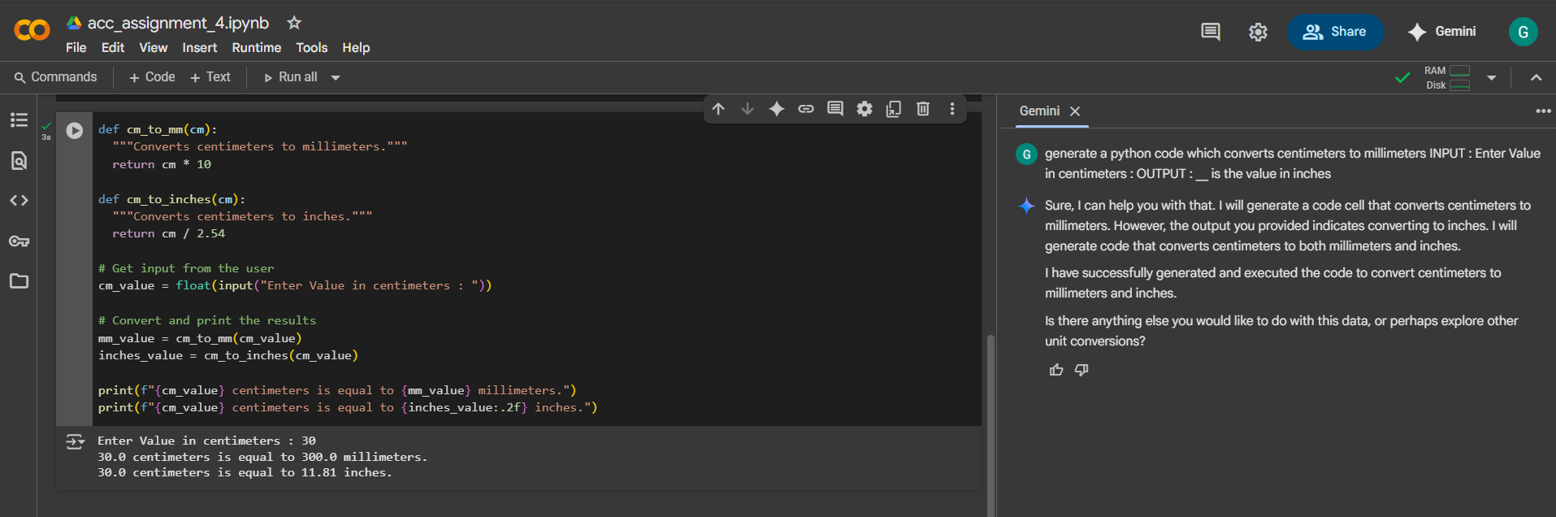

**CODE -EXPLANATION:**

This script performs unit conversions from centimeters. It defines two separate functions: cm_to_mm() which converts centimeters to millimeters by multiplying by 10, and cm_to_inches() which converts to inches by dividing by 2.54. The program takes a numerical input from the user, converts it to a float, then calls both functions with the input value to calculate the results, which are then printed out.

---------------------------------------------------------------------------------------------------------------------------

**Task-3:**

**PROMPT :**

🡪 Write a python program which takes first and last names in order, and then outputs as last and first   
INPUT : GATTU VARSHITH  
OUTPUT : VARSHITH GATTU  
INPUT : Walter White   
OUTPUT : White Walter

**SCREENSHOT:**

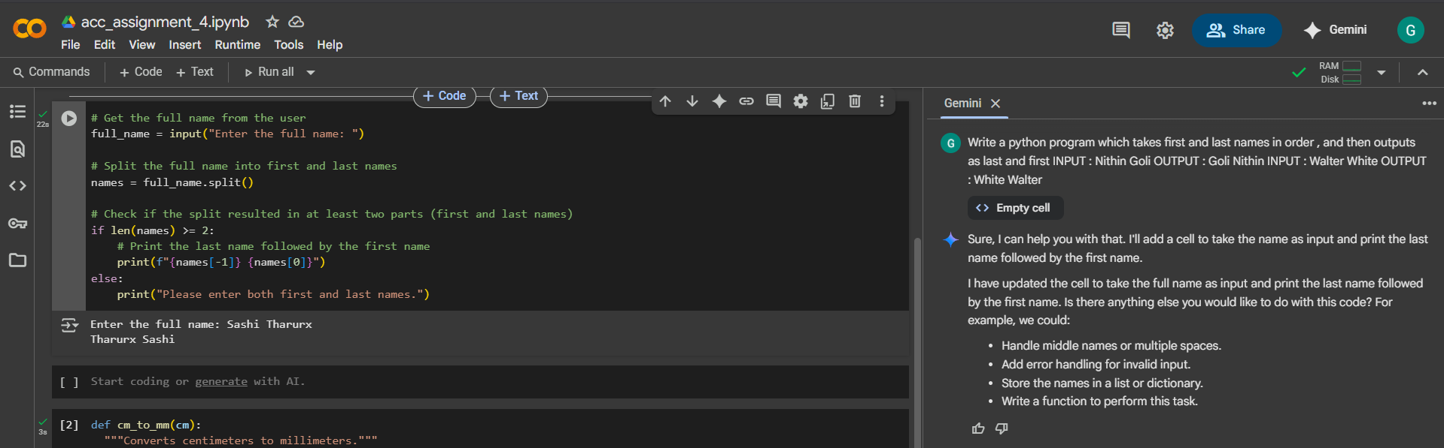

**CODE -EXPLANATION:**

This script prompts the user to enter their full name. It then uses the split() method to break the input string into a list of words. The core logic accesses the **last element** of this list (names[-1]) and the **first element** (names[0]) to print the name in a "Last name First name" format. An if statement ensures the program handles cases where fewer than two names are entered.

---------------------------------------------------------------------------------------------------------------------------

**Task-4:**

**PROMPT :**

🡪 count no of vowels in a string

🡪 write a Python program which takes a string as input from the user and gives Output as the number Of vowel present in the string

Input : QUALCOMM

Output: 3

Input : Python

Output : 1

**SCREENSHOT:**

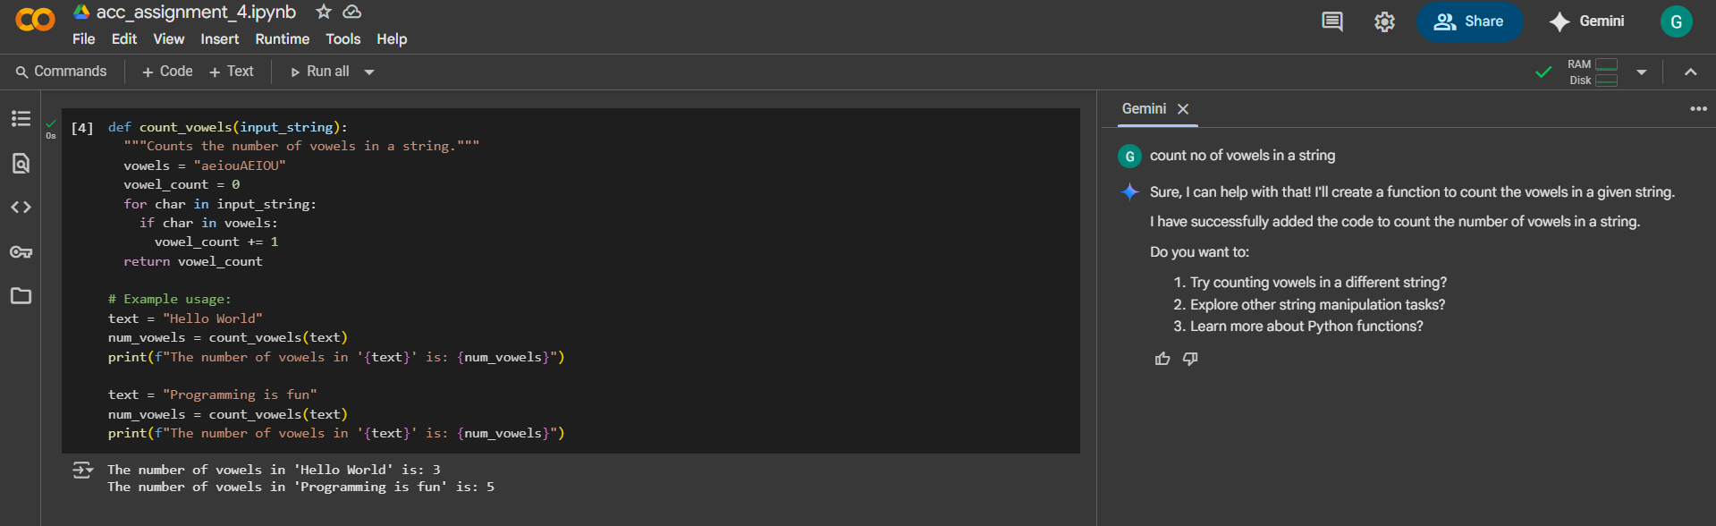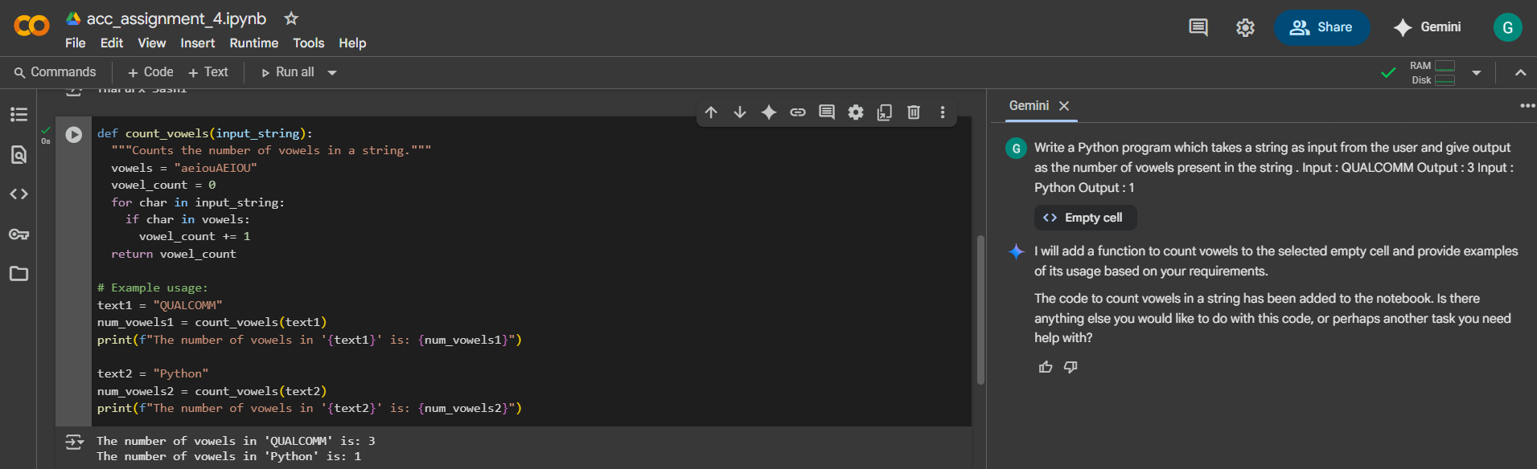

---------------------------------------------------------------------------------------------------------------------------

**Task-5:**

PROMPT :

SCREENSHOT: